Level 25 -> Level 26

The goal of the level is to Log in to bandit26 but the shell for user bandit26 is not **/bin/bash**, but something else. We need to find out what it is, how it works and how to break out of it.

Steps to follow:

1. Firstly, check what is in the directory in which currently we are of user bandit25.
2. There is a **bandit26.sshkey**, RSA key for logging into bandit26.We will use this RSA key to log into bandit26.

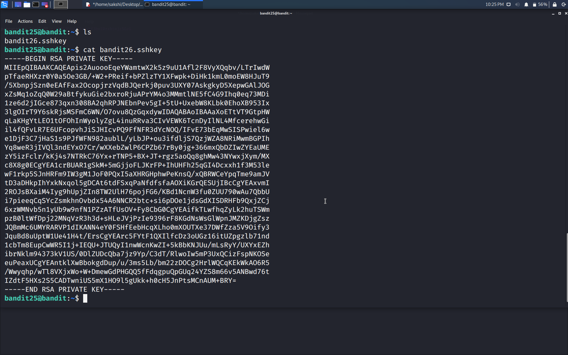

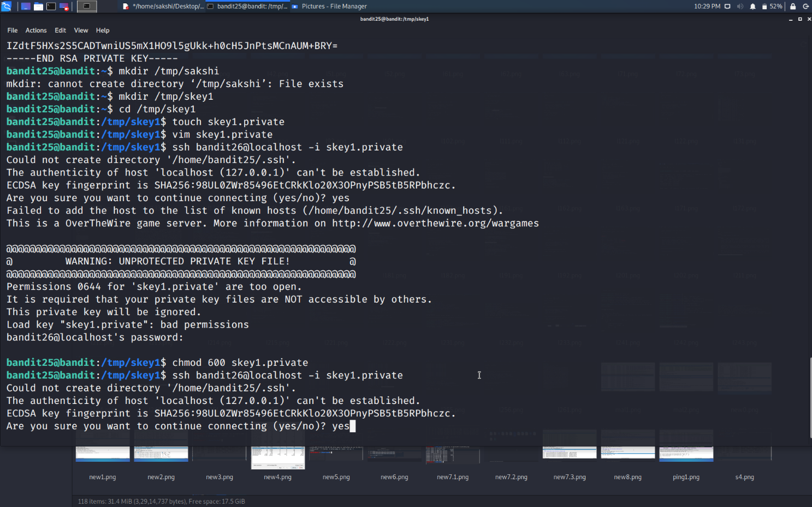

1. OOPS!!!!!! As soon as we try to connect to bandit26, **Connection to localhost is closed.**

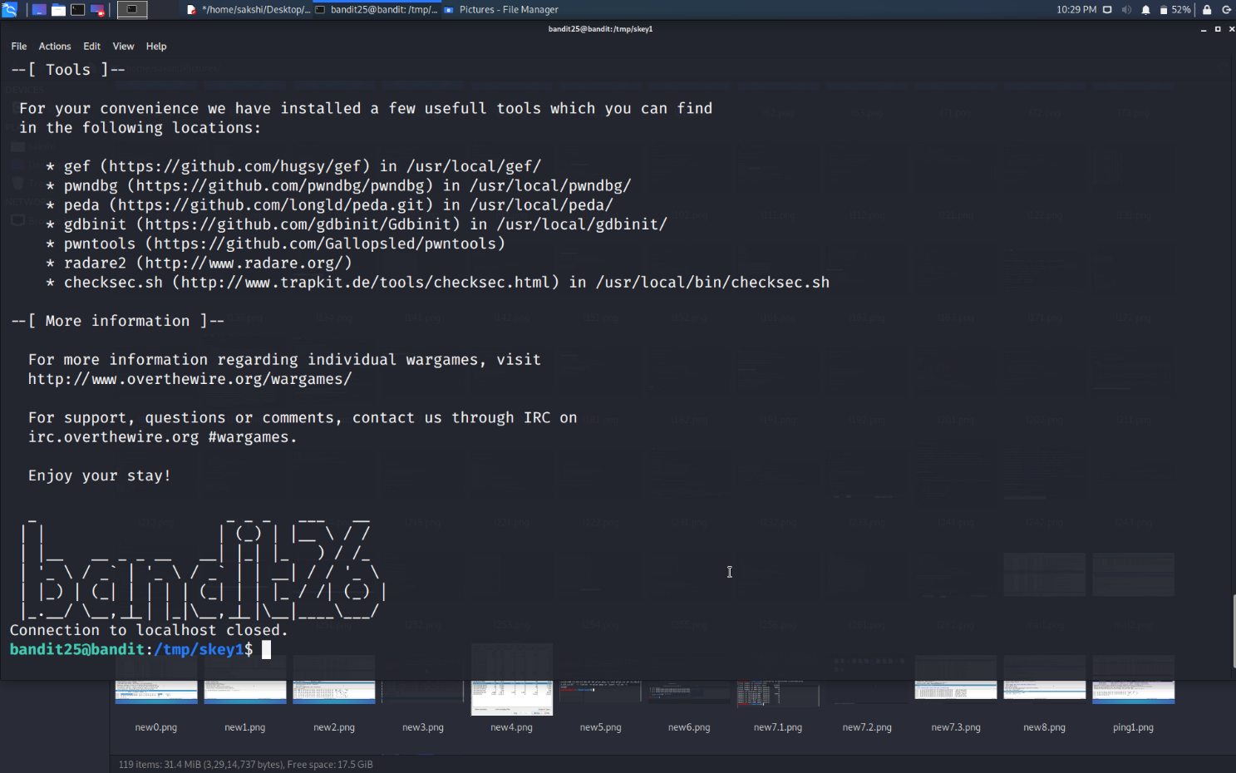

1. We will check for the reason in the **/etc/passwd** file where the information for each user and shell is available.
2. The shell for user bandit26 is **/usr/bin** and further information is present in **showtext** file. So, we will cat this file.

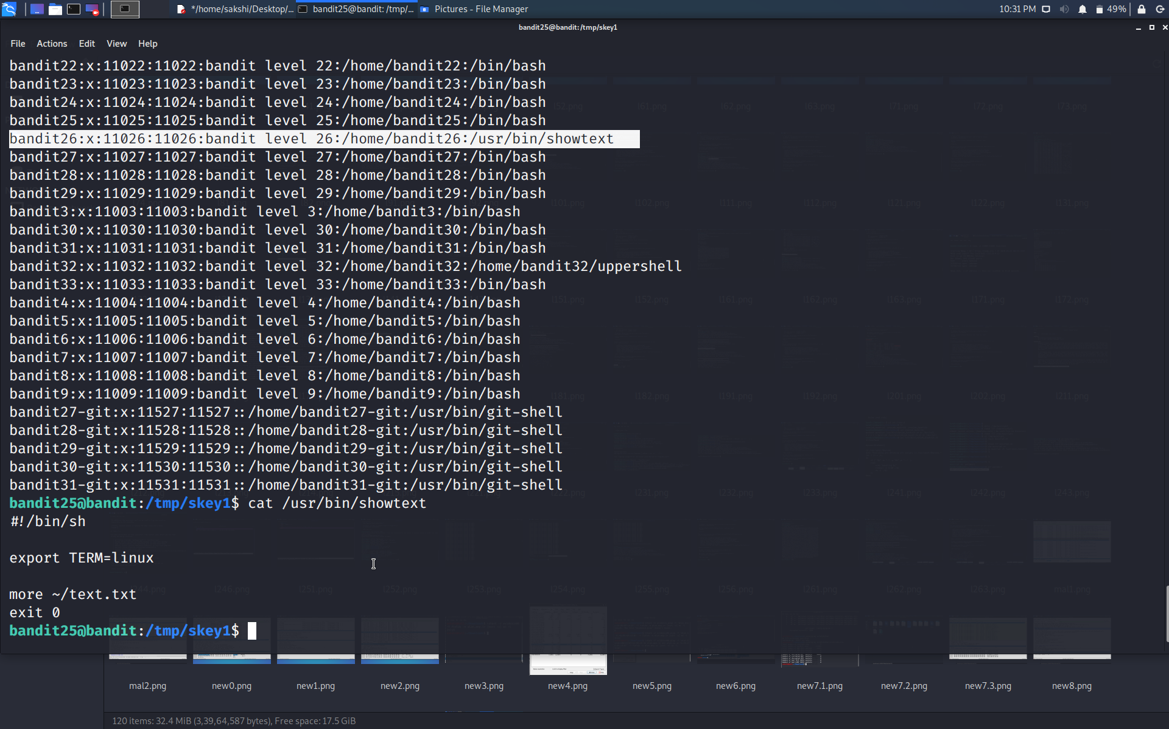

1. The script runs more command on text.txt file. **more** command is used to view the text files in the command prompt, displaying one screen at a time in case the file is large (For example log files).
2. Hence, we need to minimize the terminal size as much as possible to enter in more. Now, if we try to connect to the bandit26 using RSA key we can easily do it.

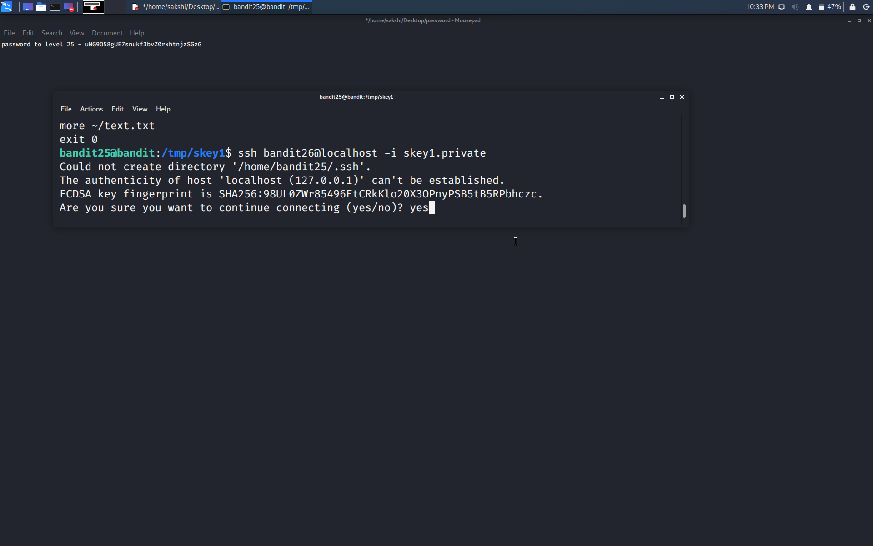

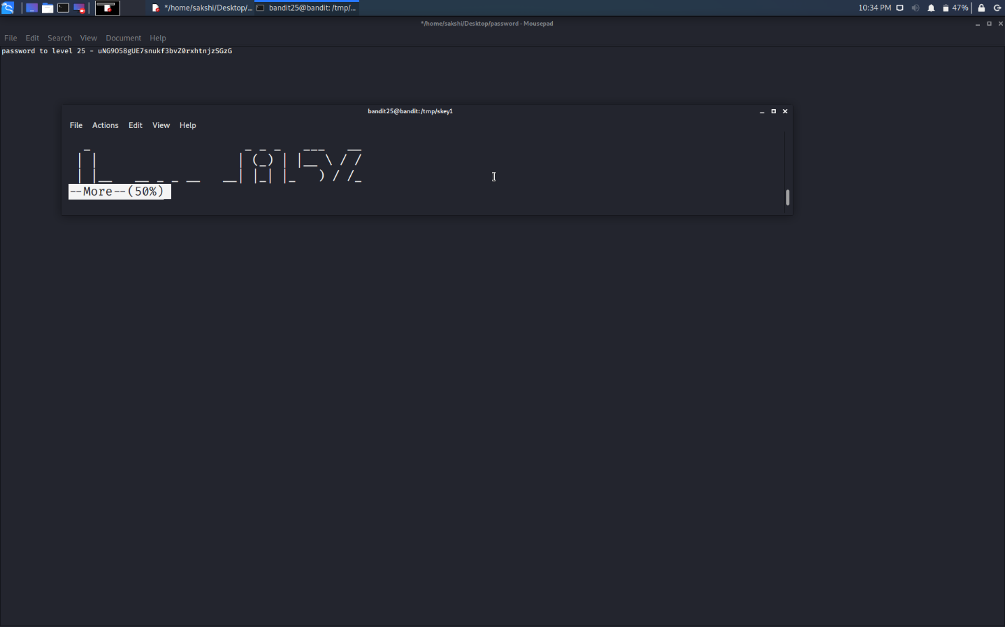

1. After it, hit **h** to get help.

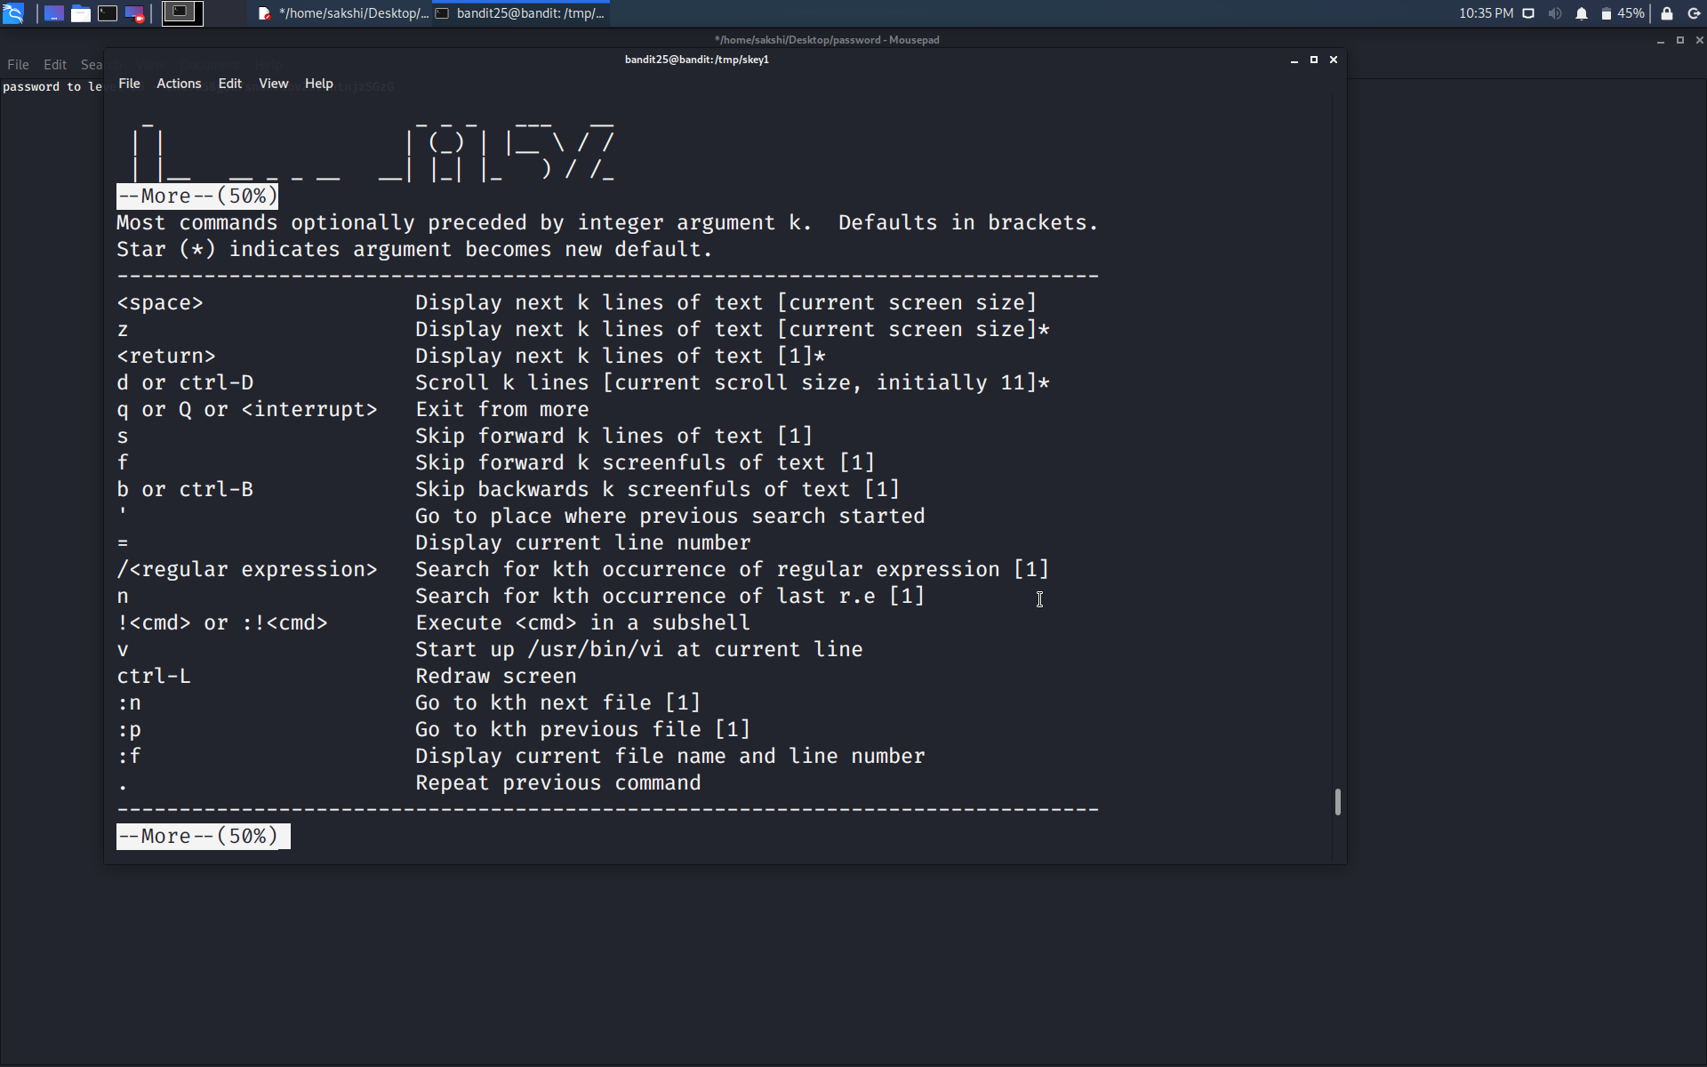

1. It shows that if we hit **v** then we cam start **/usr/bin/vi editor**.
2. Editor will open as shown below.

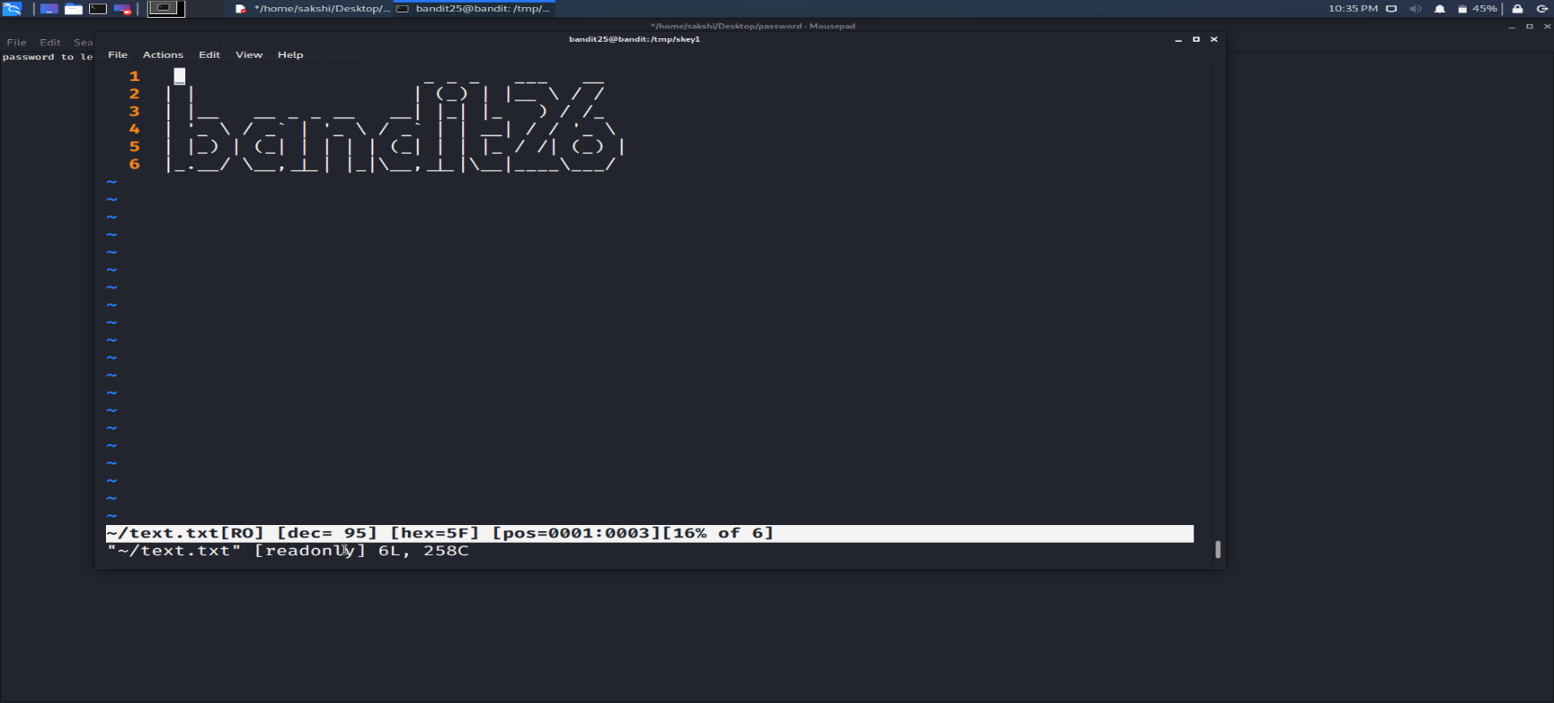

1. Since, we are user bandit26 now so we can access /etc/bandit_pass/bandit26 directly and get the password of the level 26.

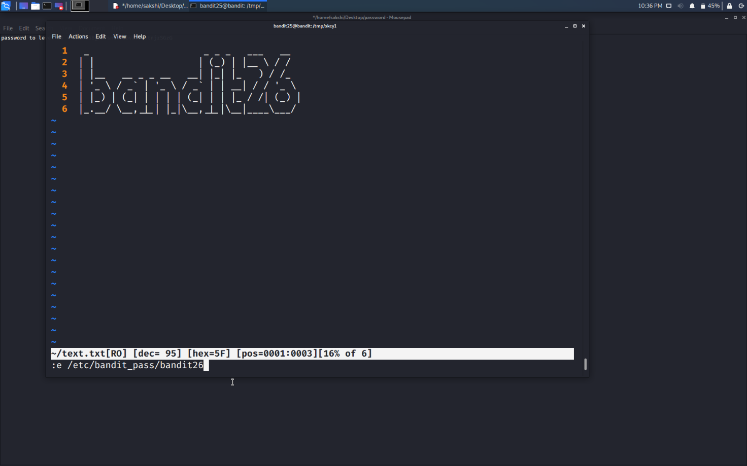

1. And here, we got the password.

